**Advance DevOps lab**

**Experiment 11**

**Name: BALOCH MUZAMMIL HAFEEZ ROLL NO: 612012**

**Semester: V**

**Branch: Information Technology**

1. **What is AWS Elastic Beanstalk?**

Ans: AWS Elastic Beanstalk is cloud deployment and provisioning service that automates the process of getting applications set up on the Amazon Web Services (AWS) infrastructure.

To use the service, developers just have to upload their applications. Provisioning, load balancing, autoscaling, and application health monitoring are all automatically handled. Elastic Beanstalk supports Web apps written in Java, Node.js, PHP Python, Ruby, and .NET, among other languages and Web development stacks. An open architecture means that applications not written for the Web can also be deployed on the Elastic Beanstalk.

The AWS Toolkit for Visual Studio and the AWS Toolkit for Eclipse allow developers to deploy and manage applications from within the integrated development environment (IDE). Developers can select elements of infrastructure management to administer, if desired.

There is no separate charge for AWS Elastic Beanstalk – customers pay only for the resources used to store and run their applications.

1. **Who should use AWS Elastic Beanstalk?**

Ans: Those who want to deploy and manage their applications within minutes in the AWS Cloud. You don’t need experience with cloud computing to get started. AWS Elastic Beanstalk supports Java, .NET, PHP, Node.js, Python, Ruby, Go, and Docker web applications.

1. **Deploy a web Application[ any language] using AWs Elastic beanstalk.**

Step 1: Login to your AWS Console.

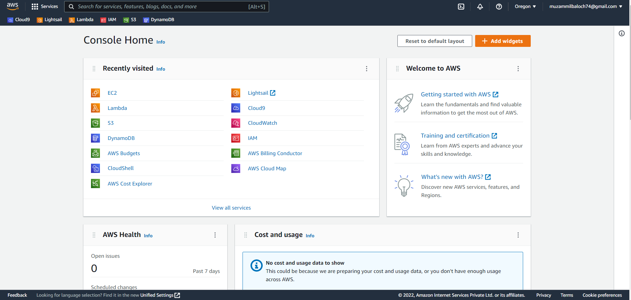

Step 2: Search Elastic Beanstalk.

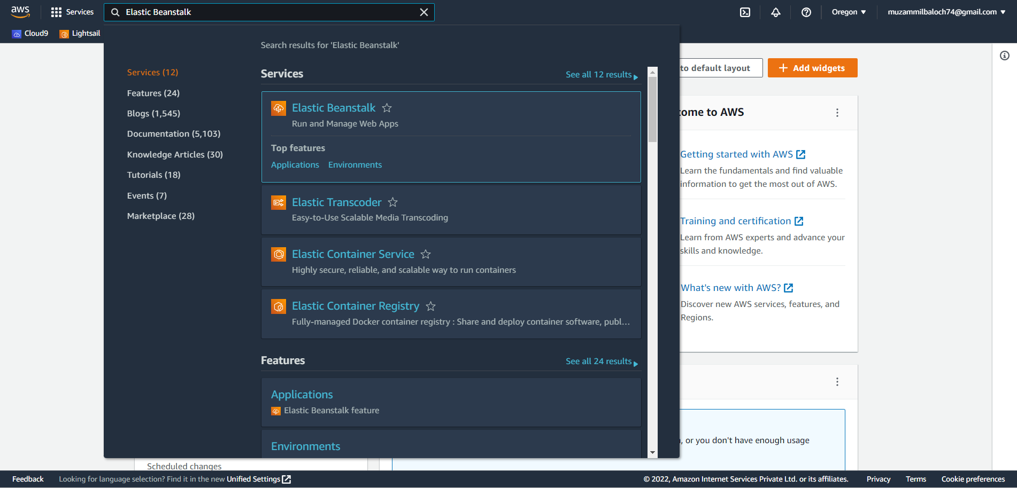

Step 3: Click on Create Application.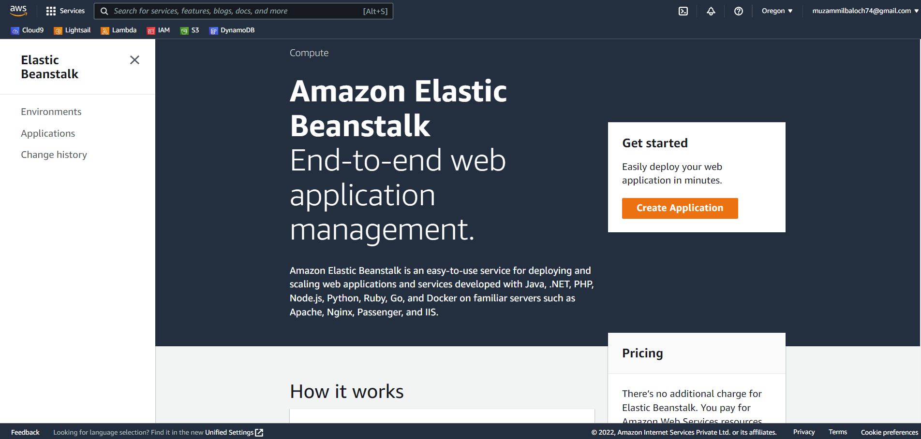

Step 4: Give a name to Application.

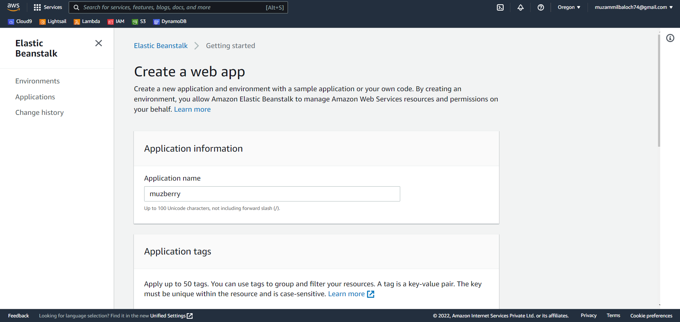

Step 5: We can select any platform so I have selected (Java) and we have to select sample code and click on Create Application.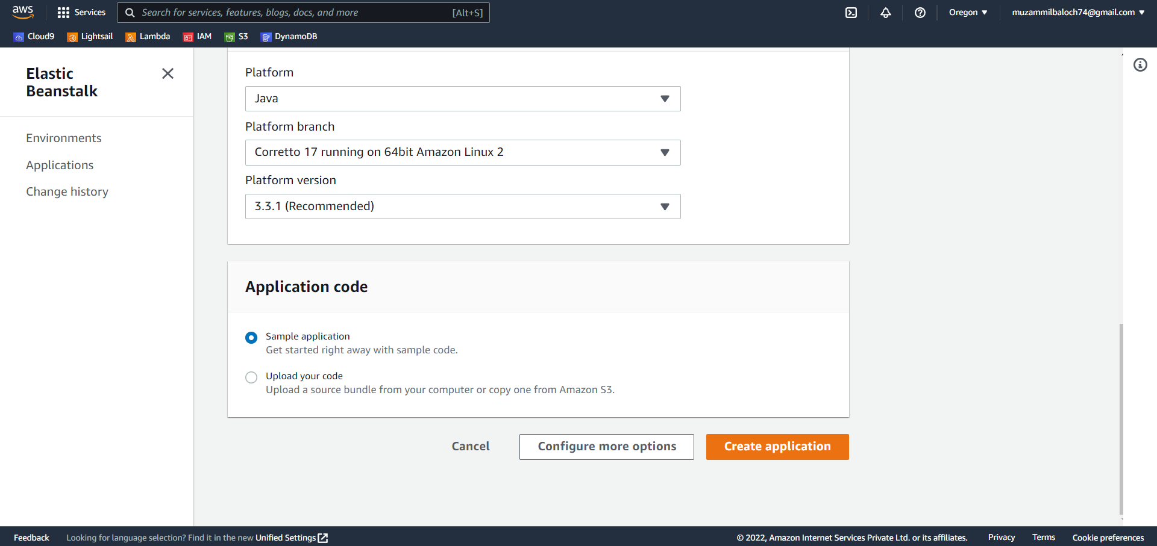

Step 6: Now its Creating the Application and it will take approx 5 to 10 mins to process.

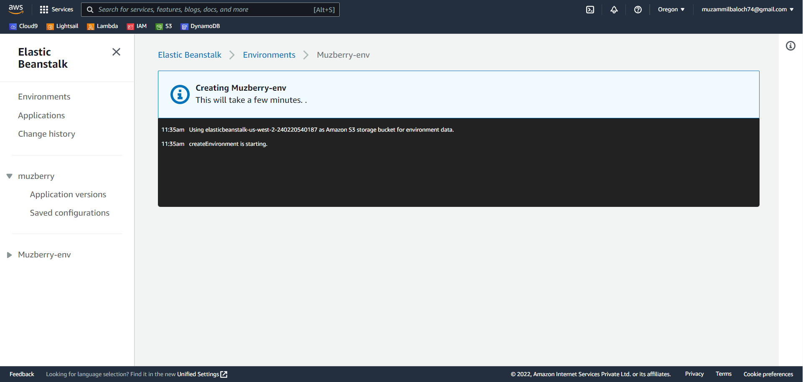

Step 7: The Application has been created (Java) & The Events.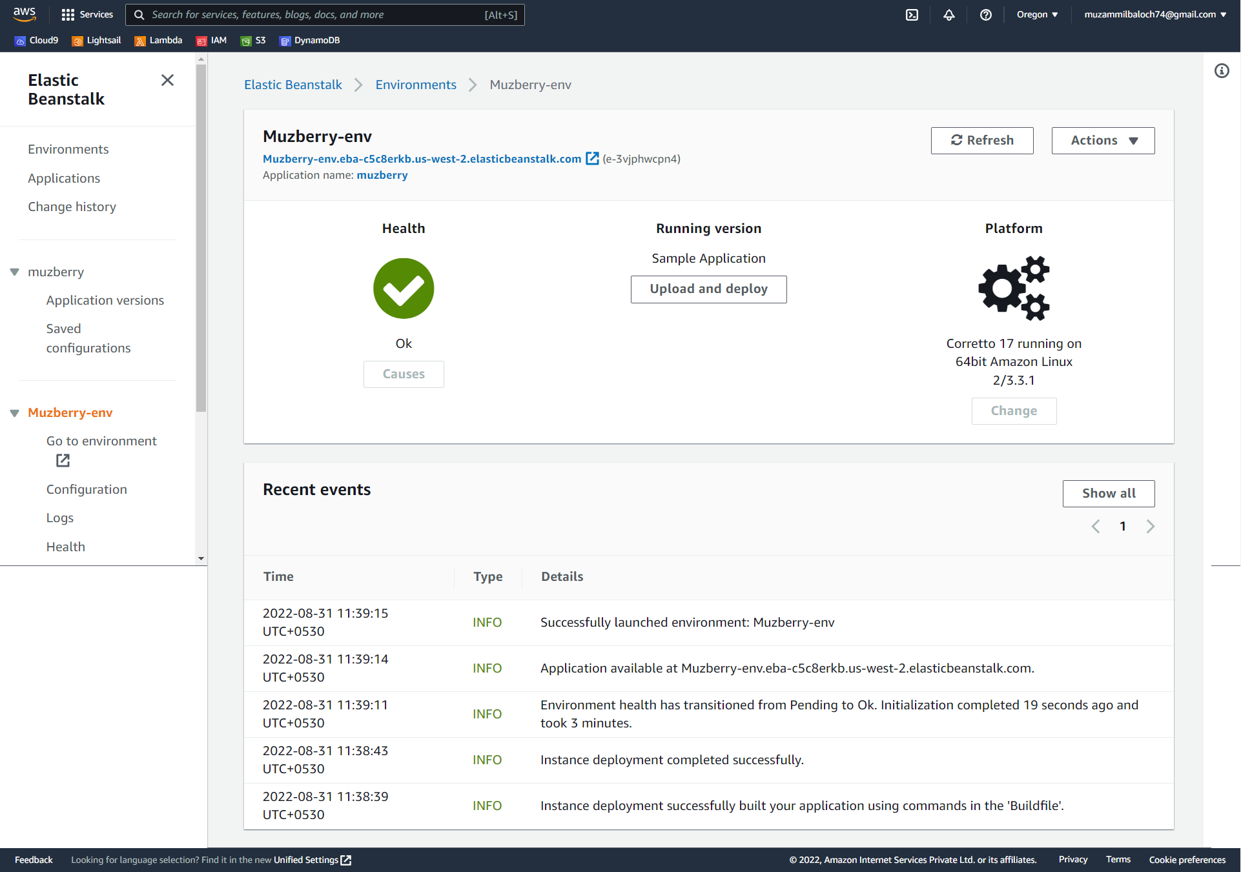

Step 8: Click on the URL given.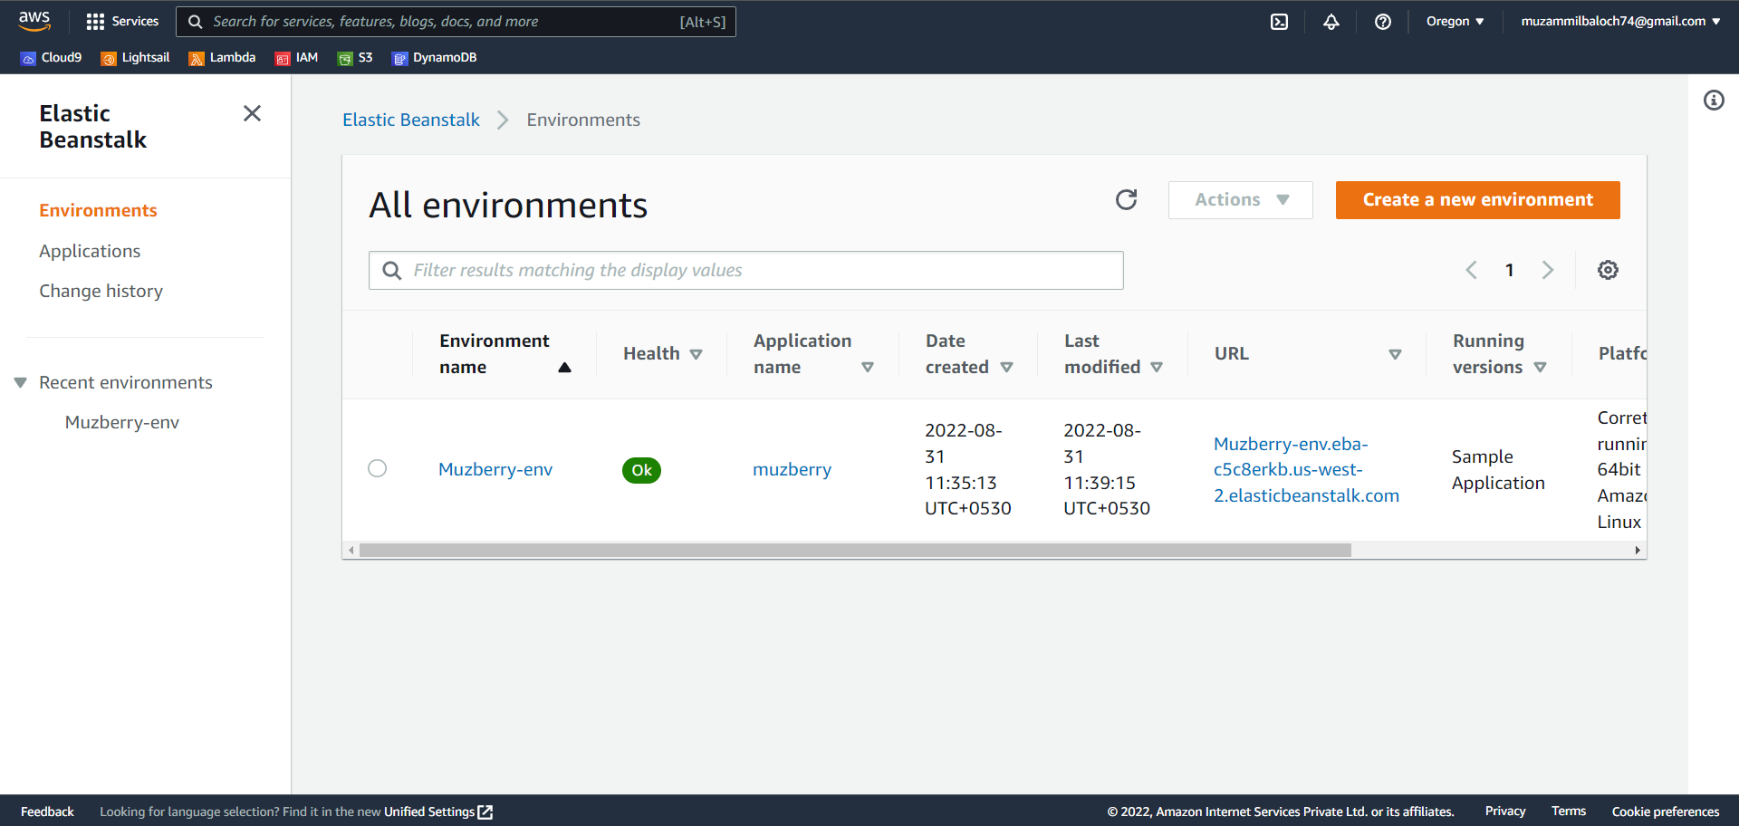

Step 9: Congratulations, your Java Application has been created.

Step 10: Now go to EC2 and click on instances.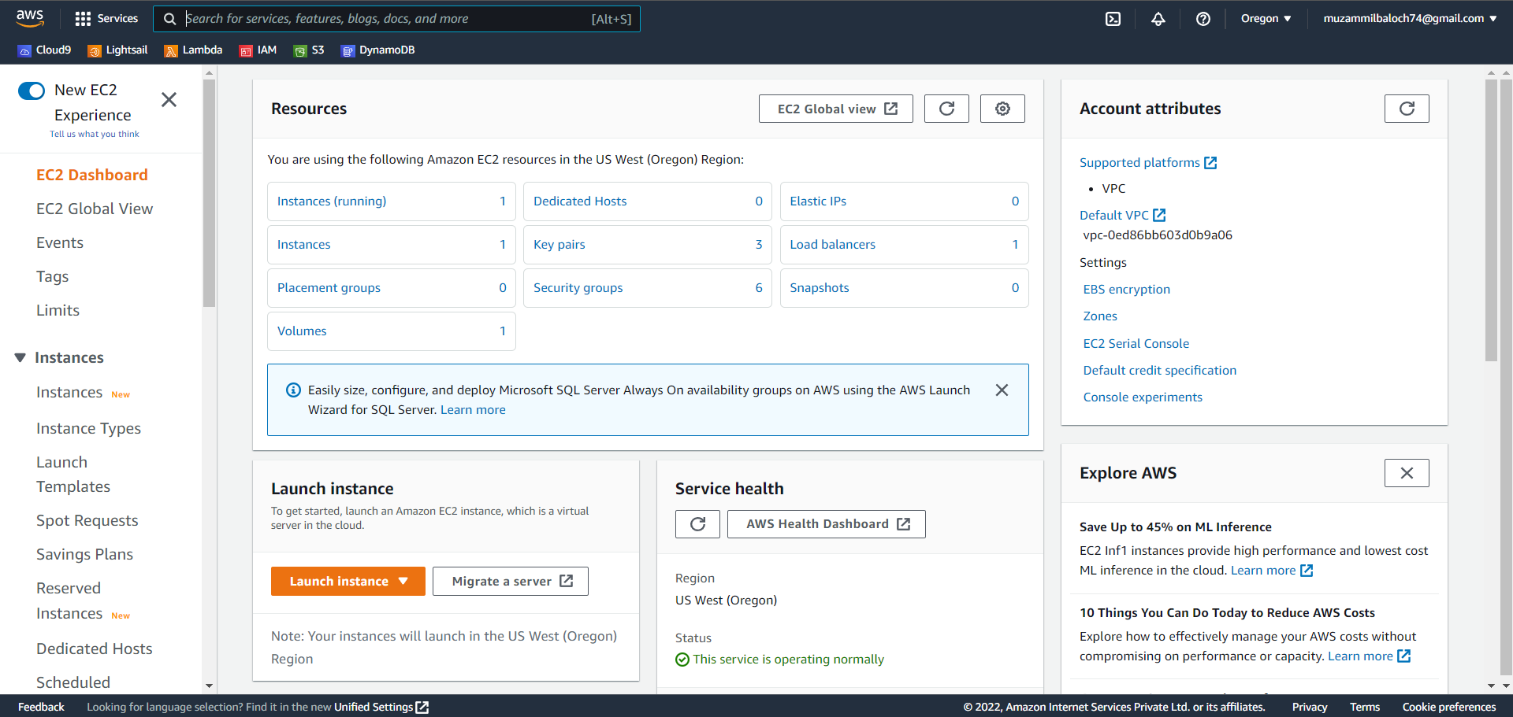

Step 11: This is the influence of Elastic Beanstalk on EC2 and now the instance running.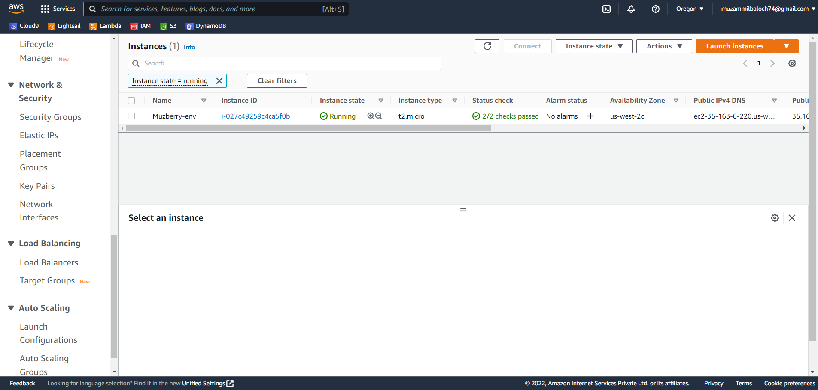

Step 12: We can see all the details of the instance.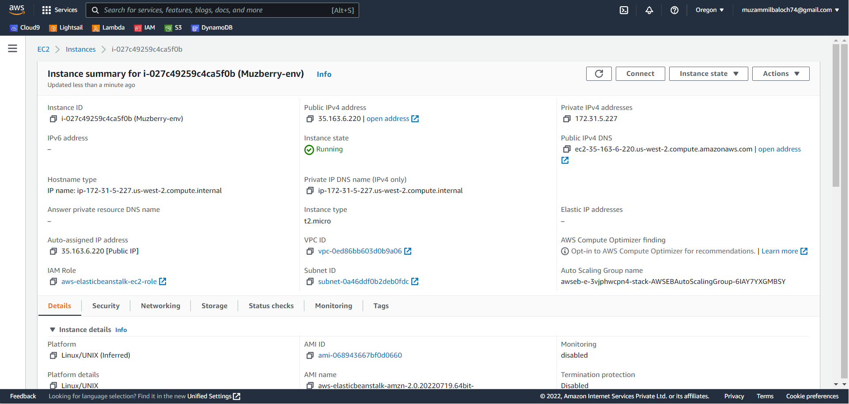

Step 13: Now terminate the instance.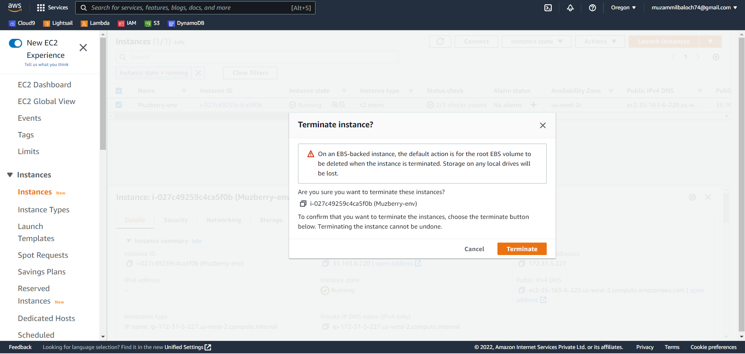

Step 14: The instance has been terminated.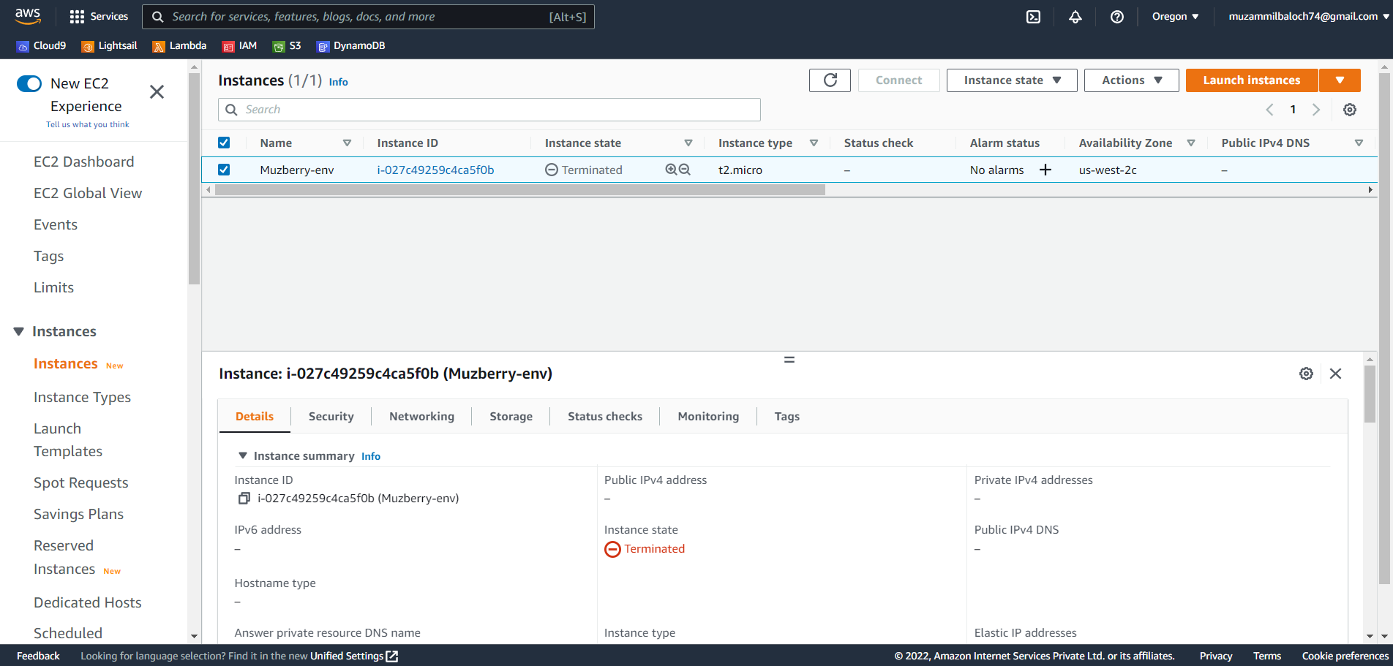

Step 15: Now terminate the Environment.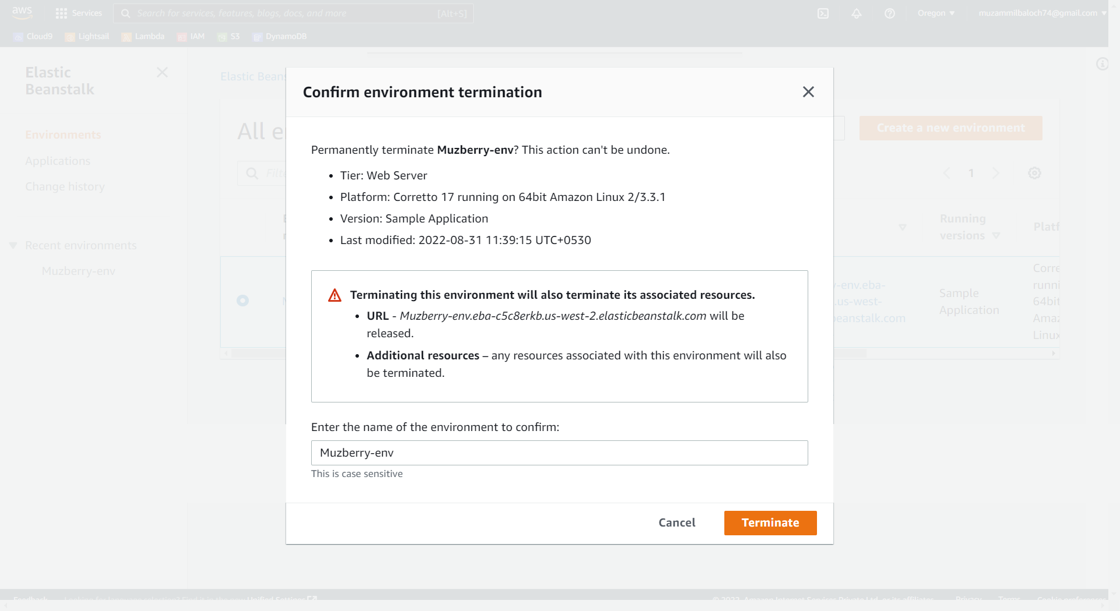

Step 16: Now delete the Application.

